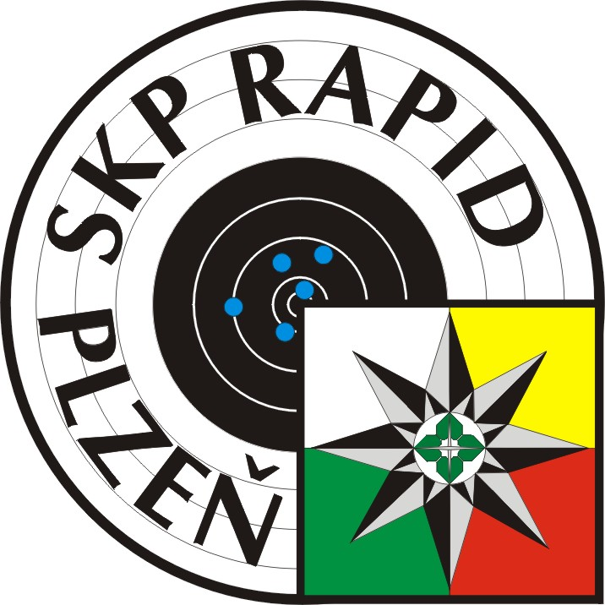


Welcome to

International Air Weapons Shooting Competition

Grand Prix



http://www.koop.cz/

from November 26nd to 28th 2009
Shooting Range Plzeň-Lobzy, Czech Republic

General Information
Grand Prix Kooperativa

Organizer : CS MV ČR and SSKP Rapid Plzeň č. 0232
Date : 26nd to 28th November 2009

Place : Indoor Shooting Range Pilsen - Lobzy
- Spieth transport target systems for paper targets (rifle on 5-target paper strips).
Finals will be conducted on Electronic Sius Ascor targets in the finals hall.

Events : 27. and 28.11. 2009
AP 60 + F, AR 60 + F, AP 40 + F, AR 40 + F,
Youth AP 40 and AR 40
Categories : # 1.- Men, # 2.- Women, # 3.- J-male, # 4.- J-female, # 5.- Youth, birth 1991+
( If a category has less than 10 competitors, categories will be combined ).
Chief of competition : Mr. Ing. Baroch Petr Economist : Mr. Huml Pavel
Main referee : Mr. Sedlák Jiří , B 4166 Chairman : Mr. Šindelář Zdeněk , B 3912

Schedule (provisional – can be changed according to final entry) :
Friday and Saturday 27th - 28th 2009
8:30 | - | 10:15 | Air Pistol 60 | M, JM
10:45 | - | 12:30 | Air Rifle 60 | M, JM
13:00 | - | 14:15 | Air Pistol 40 / Air Rifle 40 | W,, JF , Youth / W
14:45 | - | 16:00 | Air Rifle 40 | JF, Youth
Finals will be held on both days. The times will be published on the Info-table.

Training : For foreign competitors, upon request on Thu, 26nd Nov. to 18:00 o´clock
Deadline : Final Entry till November 18th 2009.
Entry fees : 40,- EUR per shooter / two days competition (cash only)
Prizes : At least three best shooters in each event and category will receive an award.
Protests : ISSF rules / 500,- CZK
Accomodation : Not arranged by organizer. Info – www.plzen.eu.
Transport : Not arranged by organizer. We will help you upon request.
Food : Shooting range-Restaurant
(open daily from 12:00 to 22:00, Monday closed, competition days open from 10:00am)

Contact us: Address : Ing.Petr Baroch, Plzeň-Lobzy 1109, 326 00 Plzeň, CzechRep
Tel./ Fax : +420 377 247 574 (office),
e-Mail : csrapidpm@email.cz www.skprapid.cz

Final Entry Form Grand Prix Kooperativa

Please return this not later than November 18th 2009 to our contact address.
Categories : # 1.- Men, # 2.- Women, # 3.- J-male, # 4.- J-female, # 5.- Youth birth 1991+

Shooting Club : Country :

Nr | Last and First Name | Birth. | Cat. | AR 60 | AP 60 | AR 40 | AP 40 | Fri | Sat
1.
2.
3.
4.
5.
6.
7.
8.
9.
10.
11.
12.
13.
14.
15.

Your Contact (Name,Fax,E-mail): ......................................................................................

Contact us: Address : Ing.Petr Baroch, Plzeň-Lobzy 1109, 326 00 Plzeň, Czech Republic
Tel./ Fax : +420 377 247 574 (office), e-Mail : csrapidpm@email.cz

Winners GP Kooperativa

GP Kooperativa records (qualification results)
Účastnické státy BIH – GBR - GER - LIE - NOR – SVK – SWE - USA - CZE (celkem 225 střelců)

1. závodní den 2. závodní den

AR 60 M Emmons Matthew USA 596 +104,4 Emmons Matthew USA 597 + 103,9
AR 60 JM Kroll David GER 589 +103,3 Kroll David GER 588 + 102,9
AR 40 W Felix Manuela GER 398 + 104,8 Kůrková Kateřina CZE 398 + 103,4
AR 40 JW Krisová Michala SVK 393 + 102,8 Kunzelman Lisa USA 394 + 102,8
AR 40 Youth Brabcová Aneta CZE 393 Vognarová Gabriela CZE 391

AP 60 M Kopp Pavol SVK 580 + 99,1 Kopp Pavol SVK 581 + 100,8
AP 60 JM Pecháček Martin CZE 580 + 97,6 Pecháček Martin CZE 579 + 101,6
AP 40 W/JW Marušková Lenka CZE 381 + 97,5 Marušková Lenka CZE 383 + 100,8
AP 40 Youth Klepáček Jan CZE 375 Klepáček Jan CZE 374

2007

Účastnické státy BIH - GER - LIE - NOR - ROM - SVK - SWE - USA - CZE (celkem 183 střelců)

1. závodní den 2. závodní den

AR 60 M Moldoveanu Alin G. ROM 596 +105 Rawlings Matthew USA 597 + 103,6
AR 60 JM Hrabovský Adam CZE 589 +100,1 Bakken Ole Magnus NOR 590 + 99,9
AR 40 W Kalná Pavla CZE 398 +103,2 Emmons Kateřina CZE 398 + 103,2
AR 40 JW Hájková Petra CZE 393 +101,2 Hoffmann Katrin GER 397 + 99,9
AR 40 Youth Jechová Marie CZE 393 Vognarová Gabriela CZE 392

AP 60 M Tenk Martin CZE 572 + 104,5 Tužinský Juraj SVK 582 + 102
AP 60 JM Sacaleanu Vlad ROM 570 + 100 Dubový Jindra CZE 577 + 98,5
AP 40 W/JW Musilová Michaela CZE 380 + 101,8 Musilová Michaela CZE 382 + 100,9
AP 40 Youth Šakičová Ludmila CZE 362 Kodedová Barbora CZE 380

2008

Účastnické státy AUT- BIH - GER - HUN - LUX - NOR - ROU - SVK - SWE - USA - CZE (celkem 201 střelců)

1. závodní den 2. závodní den

AR 60 M Moldoveanu Alin G. ROM 596 +103,9 Moldoveanu Alin G. ROM 598 + 103,5
AR 60 JM Hrabovský Adam CZE 585 +102,4 Hrabovský Adam CZE 590 + 102,8
AR 40 W Calmes Carole LUX 395 +102,3 Kalná Pavla CZE 398 + 101,4
AR 40 JW Bartošová Klára CZE 398 +101,1 Veres Kata HUN 394 + 102,7
AR 40 YouthM Hrčkulák David CZE 385 Uhlíř Vladislav CZE 386
AR 40 YouthW Mazurová Nikola CZE 390 Trojáková Lenka CZE 390

AP 60 M Tužinský Juraj SVK 580 + 91,1 Tenk Martin CZE 585 + 100,6
AP 60 JM Dubový Jindra CZE 571 + 100,2 Sacaleanu Vlad ROU 576 + 98,8
AP 40 W/JW Marušková Lenka CZE 381 + 102,6 Marušková Lenka CZE 389 + 102,1
AP 40 Youth Beerová Michaela CZE 367 Kodedová Barbora CZE 378

Rekordy základních soutěží GP Kooperativa

VzPu 60 VzPu 40
599 Debevec Rajmond SLO (1996) 399 Kůrková Kateřina CZE (2004)
599 Mohaupt Tino GER (2005) 399 Kůrková Kateřina CZE (2005)
599 Emmons Matthew USA (2005) 399 Caruso Emily USA (2005)

VzPi 60 VzPi 40
586 Kopp Pavol SVK (1998) 389 Marušková Lenka CZE (2008)

